## MINI PROJECT

**(2021-22)**

### ‘Spotify Clone’

**Project Report**



#### Institute of Engineering & Technology

##### Submitted By-

##### Anurag Gautam (201500124)

##### Saksham Sharma (201500604)

##### Prabhat Kumar(201500477)

##### Under the Supervision Of-

##### Dr. Sumit Nagar (Assistant Professor)

Department of Computer Engineering & Applications

**Department of Computer Engineering and**

**Applications**



### GLA University, 17 km. Stone NH 2, Mathura- Delhi Road,

**Chaumuhan, Mathura-281406 U.P (India)**

#### Declaration

I hereby declare that the work which is being presented in the Bachelor of

technology. Project ‘Spotify Clone’, in partial fulfilment of the requirements for the award of the Bachelor of Technology in Computer Science and Engineering and submitted to the Department of Computer Engineering and Applications of GLA University, Mathura, is an authentic record of my/our own work carried under the supervision of Dr. Manoj Varshney, Assistant Professor, Dept. of CEA, GLA University.

The contents of this project report, in full or in parts, have not been submitted to any other Institute or University for the award of any degree.

**Sign:**

**Name of Candidates:**

##### Anurag Gautam (201500124)

##### Saksham Sharma (201500604)

##### Prabhat Kumar (201500477)



#### Department of Computer Engineering and Applications GLA University, 17 km. Stone NH2, Mathura-Delhi Road, Chaumuha, Mathura-281406 U.P (India)

##### Certificate

This is to certify that the project entitled ‘Employee Management System’, carried out in Mini Project - I Lab, is a bona fide work by Anurag Gautam and Saksham Sharma, Prabhat Kumar and is submitted in partial fulfillment of the requirements for the award of the degree Bachelor of Technology (Computer Science & Engineering).

Signature of Supervisor:

Name of Supervisor: **Dr. Sumit Nagar**

Date:



#### Department of Computer Engineering and Applications

**GLA University, 17 km. Stone NH2, Mathura-Delhi**

#### Road, Chaumuha, Mathura-281406 U.P (India)

##### ACKNOWLEDGEMENT

Presenting the ascribed project paper report in this very simple and official form, we would like to place my deep gratitude to GLA University for providing us the instructor **Dr. Sumit Nagar**, our supervisor.

He has been helping me since Day 1 in this project. He provided me with the roadmap, the basic guidelines explaining on how to work on the project. He has been conducting regular meetings to check the progress of the project and providing us with the resources related to the project. Without his help, I wouldn't have been able to complete this project.

And at last but not the least we would like to thank our dear parents for helping us to grab this opportunity to get trained and also my colleagues who helped me find resources during the training.

Thanking You r Sign:

# ABSTRACT

*Human resource difficulties face all businesses, large and small. Because every organization has different staff management needs, we create custom employee management solutions that are tailored to your needs. This is intended to aid strategic planning and guarantee that your firm has the appropriate degree of human resources to meet your long-term objectives. This approach will help you to better manage your resources in the long run.*

**TABLE OF CONTENTS**

|  |  |  |
| --- | --- | --- |
| **S. No.** | **Topic** | **Page No.** |
| 1 | Declaration | 2 |
| 2 | Certificate | 3 |
| 3 | Acknowledgement | 4 |
| 4 | Abstract | 6 |
| 5 | Chapter-1: Introduction | 6 |
| 6 | Chapter-2: Objective | 6 |
| 7 | Chapter-3: Methodology | 7 |
| 8 | Chapter-4: Feasibility Study | 8 |
| 9 | Chapter-5: Implementation and Results | 9 |
| 10 | Chapter-6: Testing | 12 |
| 11 | Chapter-7: Conclusion | 13 |
| 12 | Chapter-8: Future Scope | 13 |
| 13 | Chapter-9: References | 14 |

## Introduction

Everything has been digitised in our age of ever-increasing technology. The human workforce has grown as a result of the abundance of job options. As a result, a system that can handle the data of such a vast number of people in a company where entertainment is required. Because of its user-friendly design, this project makes the process of keeping records easier. The "Spotify Clone” was created to address the issues that plagued the previous manual system. This programme is designed to eliminate, and in some cases, decrease, the problems that the current system has to eliminate data entry mistakes, the software is kept as simple as possible. When inputting incorrect data, it also displays an error notice. The user doesn’t require any formal expertise to operate this system. The admin will be able to add new employees to this project. Employee data may also be seen and printed by the administrator. Admins can also remove an employee and change their details.

## Objective

The objective of this work is to give a complete approach to personnel entertainment approach. This will be accomplished by developing and deploying an entertainment system that will result in a significant shift in the way employee data is managed.

This system's objectives include the following:

1. Design of an HR management system to meet needs such as adding and deleting songs, viewing and printing song data, and updating song information.
2. Artist data is stored in a well-designed database.
3. An easy-to-use interface that will let user interact with the system.

## Methodology

The methodology to complete this project is as follows:

1. I explored net beans, concepts of swings and applets.
2. For further and a deeper understanding, I even referred to some articles, books, journals, websites and news articles.

Below are the important concepts on which the work has been done and with the support of these I was able to work on my project.

**VS Code-** NetBeans is a Java-based integrated development environment (IDE). NetBeans enables the creation of applications using a set of modular software components known as modules. NetBeans is compatible with Windows, Mac OS X, Linux, and Solaris. It also allows other programming languages to be extended. In addition to Java programming, Third-party developers can expand NetBeans-based applications, including the NetBeans IDE.

**JAVA-** High-level, Object-Oriented programming language which help programmers to run their applications efficiently. JAVA is the programming language which comes into our minds when we talk about android application. By using JAVA as a programming language, programmer can develop any type of android application easily. JAVA also provides many libraries which also helps in making efficient android application. Swing is a Java GUI widget toolkit. It's part of Oracle's Java Foundation Classes (JFC), which provides an API for creating graphical-user- interfaces for Java programmes.

**HTML-** HTML stands for **HyperText Markup Language**. Itis a standard markup language for web page creation. It allows the creation and structure of sections, paragraphs, and links using HTML elements (the building blocks of a web page) such as tags and attributes. It’s also worth noting that HTML is not considered a programming language as it can’t create dynamic functionality. It is now considered an official web standard.

**CSS- C**ascading **S**tyle **S**heets, fondly referred to as CSS, is a simple design language intended to simplify the process of making web pages presentable.

CSS handles the look and feel part of a web page. Using CSS, you can control the color of the text, the style of fonts, the spacing between paragraphs, how columns are sized and laid out, what background images or colors are used, layout designs,variations in display for different devices and screen sizes as well as a variety of other effects.

CSS is easy to learn and understand but it provides powerful control over the presentation of an HTML document. Most commonly, CSS is combined with the markup languages HTML or XHTML.

## Feasibility Study

In order to do a feasibility study, we must consider the following:

1. **Technical Feasibility**

The availability of hardware & Software necessary for the creation of the system, as-well- as the compatibility and maturity of the technology planned to be used, and the availability of the requisite technical staff to create the system, are all factors to consider.

1. **Operational Feasibility**

Problems that may develop during operations are the focus of operation feasibility. There are two parts to this problem to consider:

* + What are the chances that the solution provided will not be used or will not work?
  + What is the inclination of-the management and end users towards the solution?

1. **Economic Feasibility**

The concept of economic feasibility is determining whether or not the potential benefit of fixing difficulties is worth while. Because member needs &alternative solutions haven’t been specified at this point, it is difficult to estimate the cost at this level.

## IMPLEMENTATION AND RESULT

Following are the screens of the Spotify Clone where you can see all the features of this system in use and you can also see the GUI of the system:

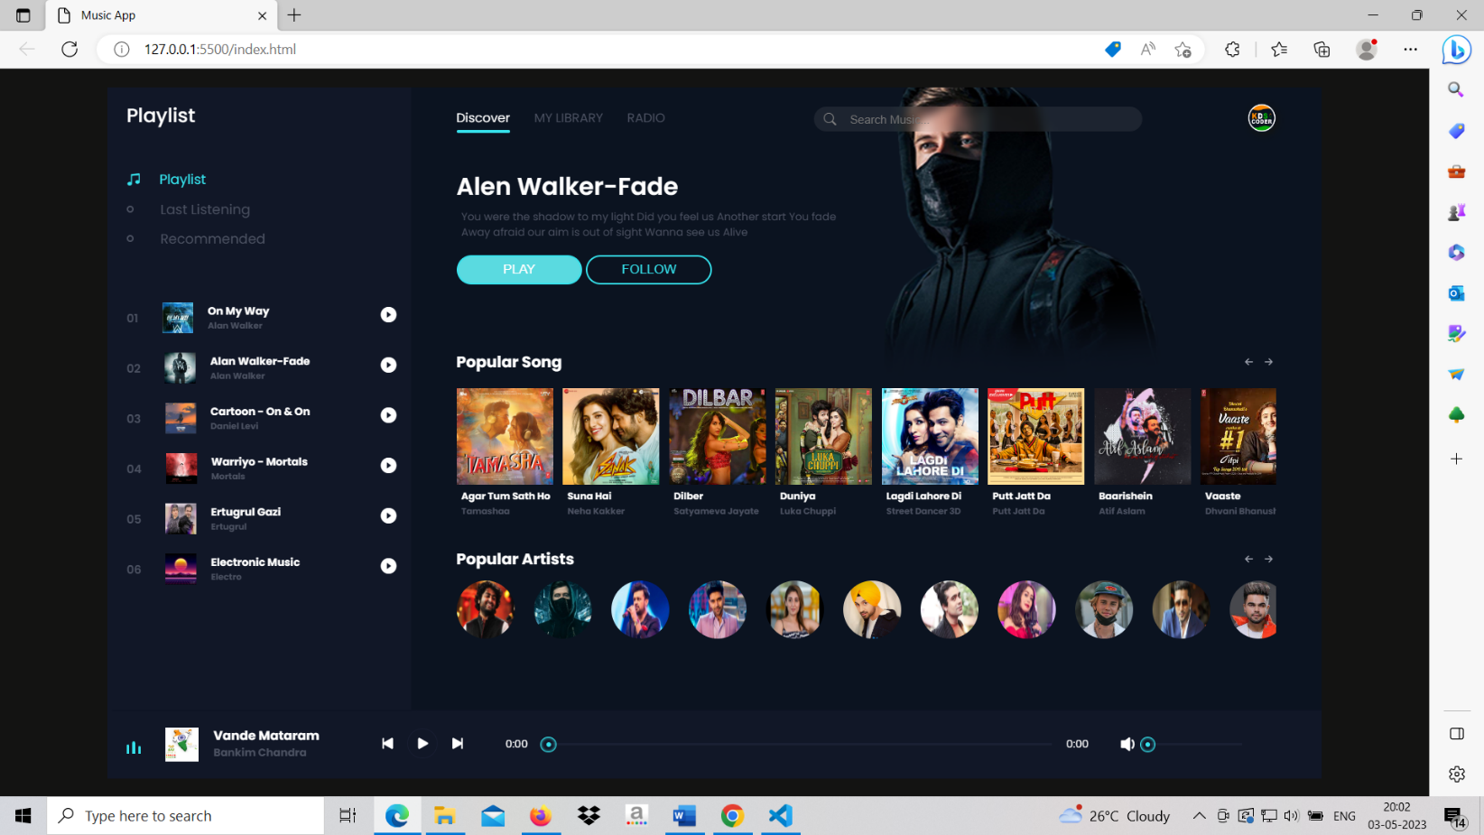

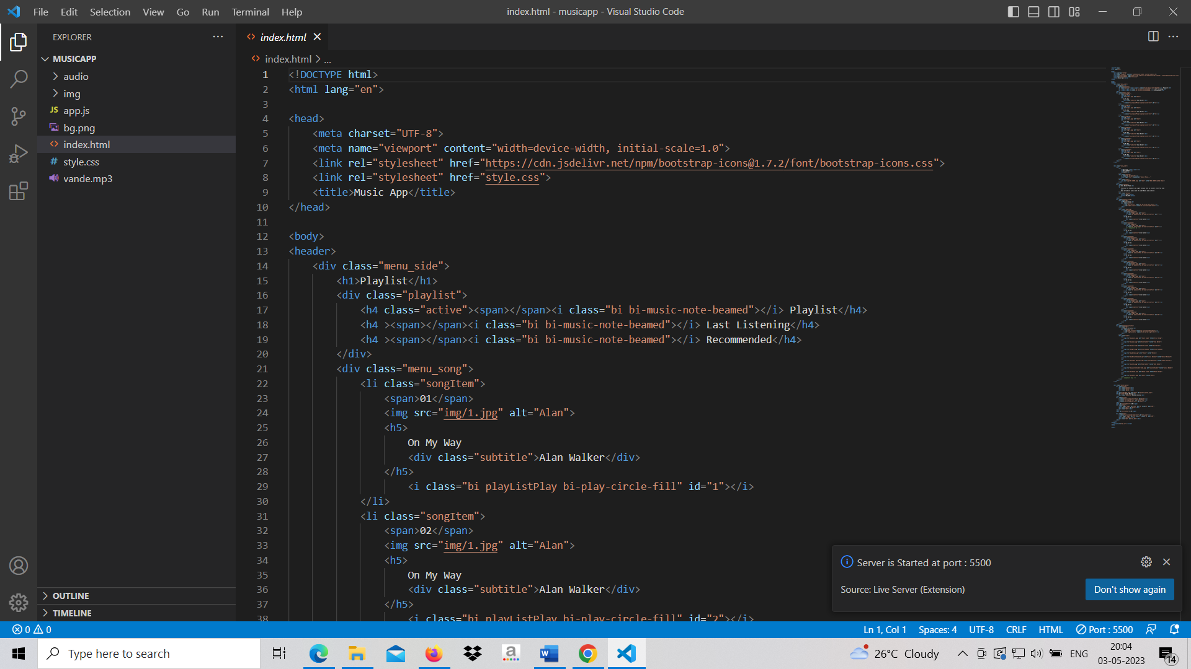

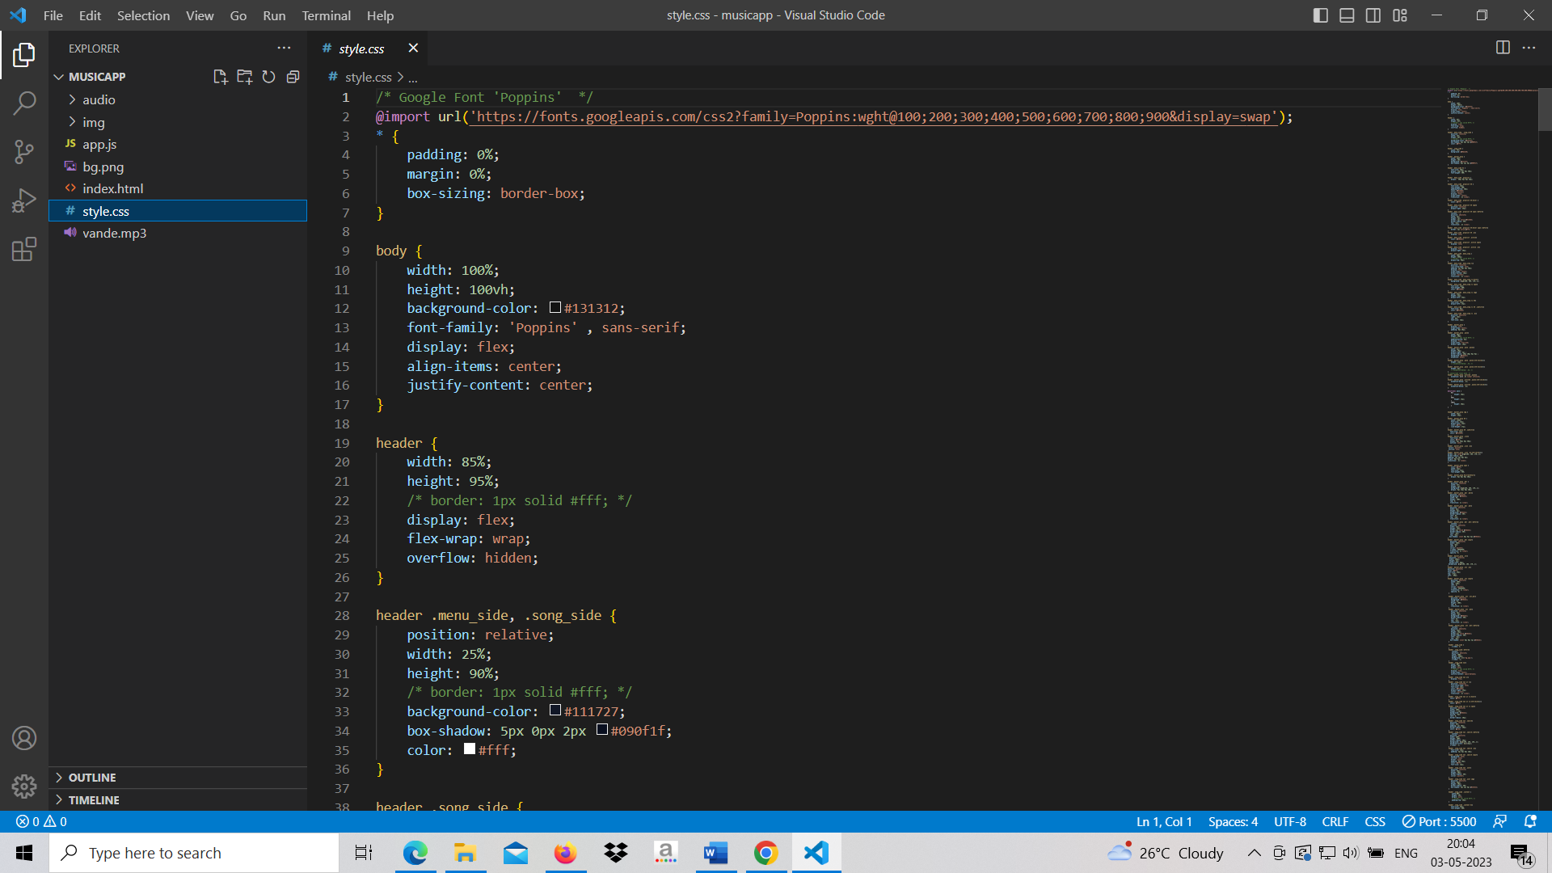

## Testing

|  |  |  |  |  |  |
| --- | --- | --- | --- | --- | --- |
| **Test ID** | **Test- Purpose** | **Test-Condition** | **Expected-Output** | **Output** | **Remark** |
| TC1 | Check Username & Password | If user details are not correct, display error message | Grant access to main dashboard. | Access granted to main dashboard | Test successful |
| TC2 | To add new user to the system | If user already exists, error message should be displayed. | New user should be added. | New user added successfully | Test Successful |
| TC3 | To view existing employee information | If employee exists, then information should be displayed, else error message should be displayed. | Employee information should be displayed. | Employee information displayed. | Test Successful |
| TC4 | To remove an employee | If employee exists, then employee should be removed else error message should be displayed. | Employee should be removed. | Employee removed successfully. | Test Successful |
| TC5 | Update employee information | If employee exists, then information should be updated. | Employee information should be updated. | Employee information updated successfully | Test Successful |

1. **Conclusion**

The goal of the initiative is to digitise personnel databases in businesses and provide administrators access to computers. Employees and administrators use software as an information system. The user can store his or her database safe and secure for an indefinite amount of time here. Adding, deleting, accessing, and changing employee information is simple and easy using the Employee Management System.

## Future Scope

The GUI and the features added to this system are the basic ones. In future, there will be a better Graphical User Interface and there will be more features added to this system. If Graphical User Interface is improved then this system will be more user friendly and more features added will make this system a lot better and HR will be able to perform more operations.

## References

* 1. Renae Broderick, John W. Boudreau, “Human resource management, information technology, and the competitive edge”, Academy of Management Executive, 1992 Vol. 6 No. 2
  2. Julie Bulmash, “Human Resource Management and Technology”, Chapter 3.
  3. Ian Sommerville, “Software Engineering”, 9th Edition, Addison-Wesley, 2011.
  4. Avison, D. and Fitzgerald, G. (2003).Information systems Development Methodologies, Techniques and Tools.3rd Edition. McGraw-Hill Education Limited Bershire
  5. Juan Manuel Munoz Palacio, Information systems development methodologies for Data-driven Decision Support Systems, 2010.
  6. Deitel, PJ & Deitel, HM, 2008, Internet & World Wide Web How To Program,Dorling Kindersley, India.